Overview of most significant contributors in 2016 Federal Election Commission Data for Bernie Sanders

1) **Occupation**: On visualizing occupation of all the contributors, we can see ‘not employed’ people have contributed most and after that ‘Retired’, ‘Teachers/professors’, ‘Attorney’, ‘Software engineer’, ‘Engineer’ and ‘Physicians’ have contributes in the above order. In this visualization I have grouped all the teachers

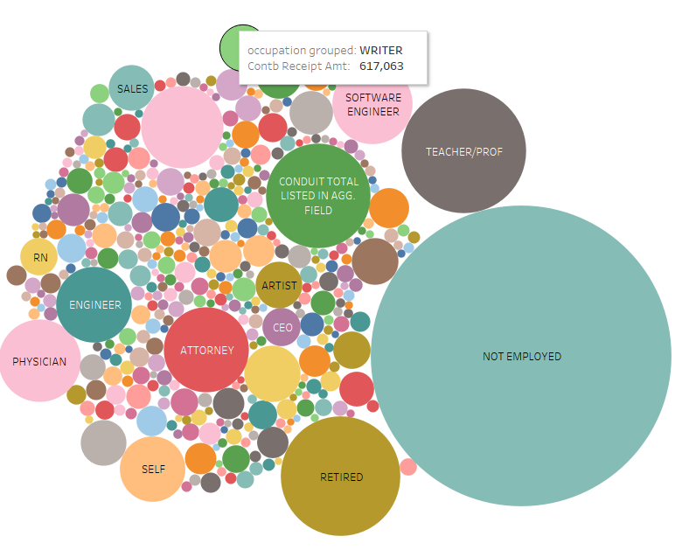

2) **Employer**: Most people who contributed in this election commission were ‘Self Employed’ or are in a category named ‘Information requested’. There are ‘Retired’ and ‘Unemployed’ categories included in this visualization on 3rd and 4th rank respectively. After that we can see there are employers like ‘Google’, ‘Microsoft’, ‘IBM’, ‘Freelance’, ‘USPS’, ‘Kaiser permanent’, ‘AT&T’ etc.

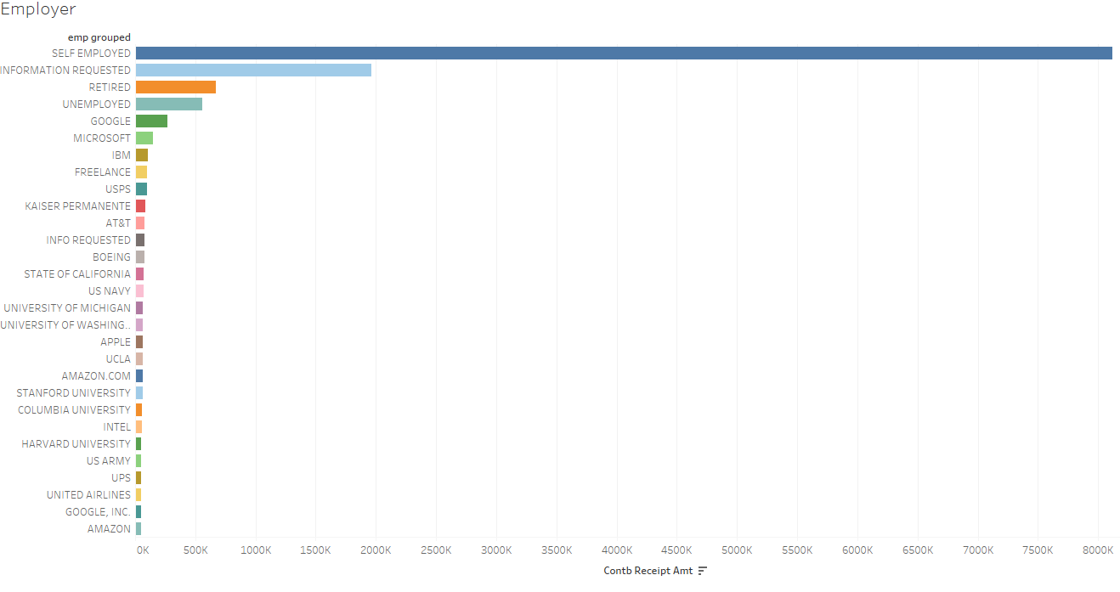

3) **State**: As we can see in the following visualization snap, California was the biggest contributor state in this election for Bernie, after that New York, Massachusetts, Washington, Texas, Florida have contributed in the specified order.

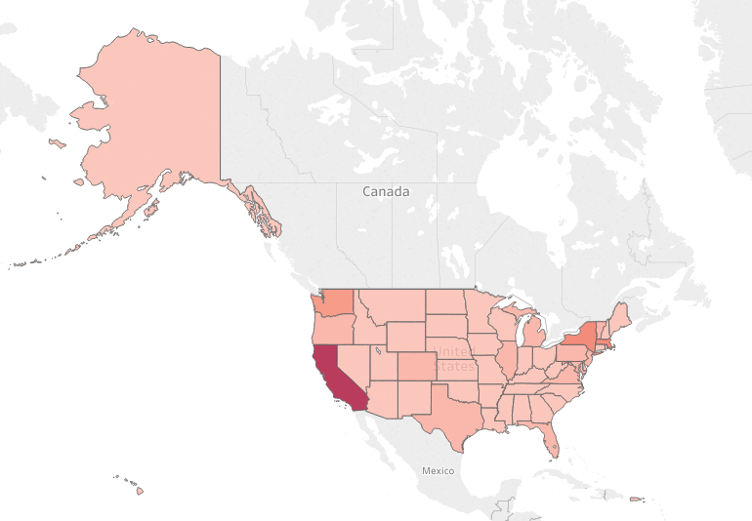

4) **Rate Over Time:**

On visualizing line graph of ‘rate over time’, we can see the rate had increased rapidly after December 2015 and had reached to its highest peak in February 2016 and dropped sharply after that. The rate started to increase again in June 2016 and had stagnant rate after August 2016.

